**A PROJECT REPORT ON**

**TOWARDS A SECURE TRAVEL ASSISTANCE DEVICE FOR GPS/GPRS ENABLED**

**MOBILE USERS TO AID TRANSIT RIDERS WITH SPECIAL NEEDS.**

SUBMITTED TO THE UNIVERSITY OF PUNE, PUNE

IN THE PARTIAL FULFILLMENT OF THE REQUIREMENTS

FOR THE AWARD OF THE DEGREE

OF

**BACHELOR OF ENGINEERING (COMPUTER ENGINEERING)**

##### SUBMITTED BY

**Sourabh Gavhale Exam No: B80364241**

**Suyash Jadhav Exam No: B80364255**

**Swapnil Mahajan Exam No: B80364284**

**Apurva Inamdar Exam No: B80364251**



## DEPARTMENT OF COMPUTER ENGINEERING

## STES’S SMT. KASHIBAI NAVALE COLLEGE OF ENGINEERING

**VADGAON BK, OFF SINHGAD ROAD, PUNE 411041**

**UNIVERSITY OF PUNE**

## 2012 - 13

**CERTIFICATE**

This is to certify that the project report entitles

**“Towards a Secure Travel Assistance Device for GPS Enabled**

**Mobile Users to Aid Transit Riders with Special Needs.”**

Submitted by

**SOURABH GAVHALE** **EXAM NO: B80364241**

**SUYASH JADHAV**  **EXAM NO: B80364255**

**SWAPNIL MAHAJAN**  **EXAM NO: B80364284**

**APURVA INAMDAR**  **EXAM NO: B80364251**

is a bonafide work carried out by them under the supervision of **Prof. Suwarna Baheti** and it is approved for the partial fulfillment of the requirement of University of Pune, for the award of the degree of **Bachelor of Engineering** (Computer Engineering).

This project work has not been earlier submitted to any other Institute or University for the award of any degree.

**(Prof. Suwarna Baheti)** **(Prof. Pratikshit Mahalle)**

Internal Guide Head,

Department of Computer Engineering Department of Computer Engineering

**(Dr. A. V. Deshpande)**

Principal,

Smt. Kashibai Navale College of Engineering Pune – 41

Place: Pune

Date:

**SPONSORSHIP LETTER**

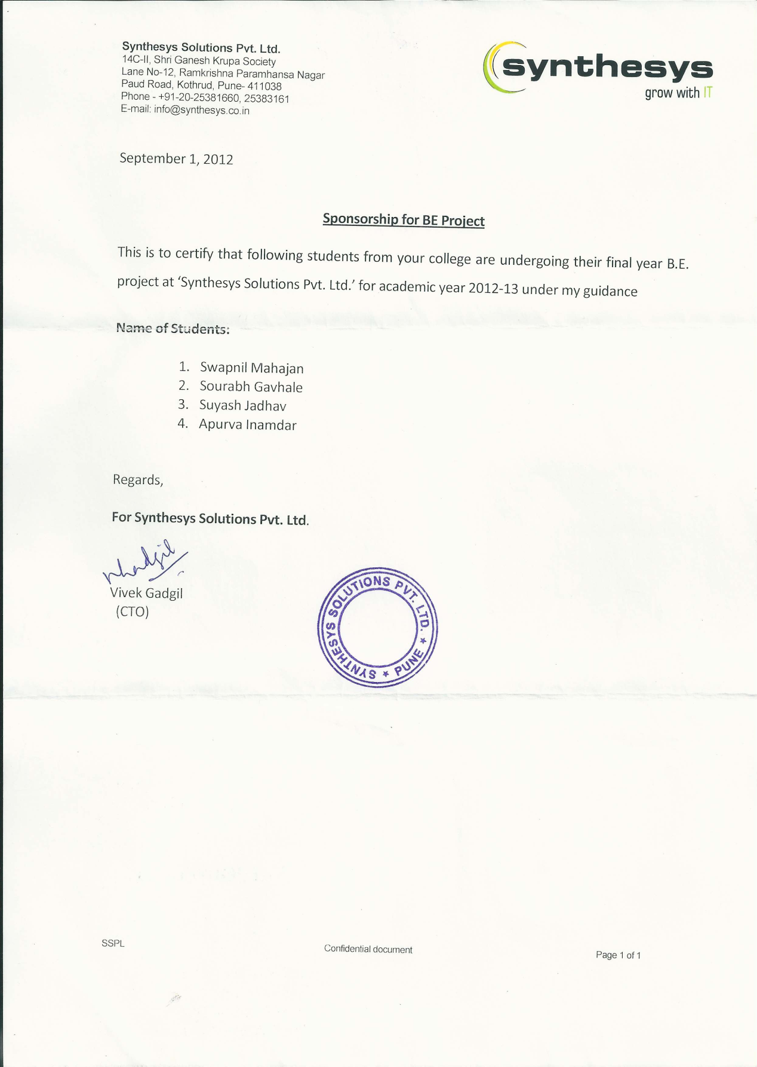

**ACKNOWLEDGEMENT**

We take this opportunity to thank for the invaluable help and support we have received directly and indirectly during the course of the project.

We would like to express our deep sense of gratitude to our **External guide Mr. Vivek Gadgil** for his valuable assistance and guidance in executing our project and constant support. It gives us proud privilege to work for the project under the guidance of our **Internal guide Prof. Suwarna Baheti**. We would also like to express our gratitude towards **Prof. Pratikshit Mahalle** **(HOD of Computer)** for providing all facilities and every help for the smooth progress of project Work.

Our gratitude also extends to our principal **Prof. A. V. Deshpande** and all Staff Members of Computer department for timely help and encouragement for fulfillment of Project work.

Sourabh Gavhale

Suyash Jadhav

Swapnil Mahajan

Apurva Inamdar

**ABSTRACT**

As urban living environment is becoming more e and more complex, the road condition is becoming worse because of heavy traffic, tremendous increase in accidents and most importantly the security issues that have been raised by recent incidences. To solve such problem with respect to school going children, school bus tracking system has been developed. A school bus tracking system determines the position of the bus with a GPS/GPRS enabled cell phone and displays the position on a Google map.

School Bus tracking technology meets the security expectations of parents of school going children by providing features as Alert messages, various Notifications and Conformance of Attendance of the child on the bus.

**TABLE OF CONTENTS**

LIST OF ABBREVATIONS I

LIST OF FIGURES II

LIST OF TABLES III

# CHAPTER TITLE PAGE NO

|  |  |  |  |  |  |  |  |  |  |  |
| --- | --- | --- | --- | --- | --- | --- | --- | --- | --- | --- |
| Sr.No. | | | | | | | Chapters | | | Page No. |
| 01 | | | | | | | Introduction | | | 1 |
|  | | | | | | | 1.1 Introduction | | | 1 |
| 1.2 Problem Definition | | | 1 |
| 1.3 Overview | | | 2 |
| 02 | | | | | | | Literature Survey | | | 3 |
| 03 | | | | | | | Software Requirements Specification | | | 9 |
|  | 3.1 | | | | | | Introduction | | | 9 |
|  |  | | | | | | 3.1.1 | Project Scope | | 9 |
|  |  | | | | | | 3.1.2 | User Classes and Characteristics | | 9 |
|  |  | | | | | | 3.1.3 | Assumption and Dependencies | | 10 |
|  | 3.2 | | | | | | System Features | | | 10 |
|  |  | | | | | | 3.2.1 | Registration | | 10 |
|  |  | | | | | | 3.2.2 | Scanning | | 10 |
|  |  | | | | | | 3.2.3 | Location Tracking | | 11 |
|  |  | | | | | | 3.2.4 | Display Location | | 11 |
|  | 3.3 | | | | | | External Interface Requirements | | | 11 |
|  |  | | | | | | 3.3.1 | User Interfaces | | 11 |
|  |  | | | | | | 3.3.2 | Software Interfaces | | 11 |
|  |  | | | | | | 3.3.3 | Hardware Interfaces | | 11 |
|  |  | | | | | | 3.3.4 | Communication Interfaces | | 12 |
|  | 3.4 | | | | | | System Features and Functional Requirements | | | 12 |
|  | 3.5 | | | | | | Non Functional Requirements | | | 13 |
|  |  | | | | | | 3.5.1 | Performance Requirements | | 13 |
|  |  | | | | | | 3.5.2 | Safety Requirements | | 13 |
|  |  | | | | | | 3.5.3 | Security Requirements | | 13 |
|  |  | | | | | | 3.5.4 | Software Quality Attributes | | 14 |
|  | 3.6 | | | | | | **Other Requirements** | | | 14 |
|  |  | | | | | | 3.5.1 | Database Requirements | | 14 |
|  |  | | | | | | 3.5.2 | Reuse Objectives for the Project | | 15 |
| 04 | | | | | | | System Design | | | 16 |
|  | 4.1 | | | | | | Selection of Life Cycle Model | | | 16 |
|  |  | | | | | | 4.1.1 | | Scope | 16 |
|  |  | | | | | | 4.1.2 | | Planning | 17 |
|  |  | | | | | | 4.1.3 | | Initiation | 17 |
|  |  | | | | | | 4.1.4 | | Construction Iterations | 17 |
|  |  | | | | | | 4.1.5 | | Release Iterations | 17 |
|  |  | | | | | | 4.1.6 | | Productions | 17 |
|  |  | | | | | | 4.1.7 | | Retirements | 17 |
|  | 4.2 | | | | | | System Implementation Plan | | | 19 |
|  | 4.3 | | | | | | Data Flow Diagram | | | 20 |
|  | 4.4 | | | | | | Class Diagram | | | 21 |
|  | 4.5 | | | | | | Use Case Diagram | | | 24 |
|  | 4.6 | | | | | | Sequence Diagram | | | 25 |
|  | 4.7 | | | | | | Activity Diagram | | | 27 |
|  | 4.8 | | | | | | Deployment Diagram | | | 28 |
| 05 | | | | | | | System Architecture | | | 29 |
|  | 5.1 | | | | | | Overview | | | 29 |
|  | 5.2 | | | | | | System Architecture | | | 30 |
|  | 5.3 | | | | | | Algorithm | | | 32 |
|  |  | | | | | | 5.3.1 | | On Child device | 32 |
|  |  | | | | | | 5.3.2 | | On Parent device | 32 |
|  |  | | | | | | 5.3.3 | | On server side | 32 |
|  | 5.4 | | | | | | Flowchart | | | 34 |
|  |  | | | | | | 5.4.1 | | Child Application | 34 |
|  |  | | | | | | 5.4.2 | | Parent Application | 35 |
| 06 | | | | | | | **Technical Specification** | | | 36 |
|  | 6.1 | | | | | | Technology Details used in Project | | | 36 |
|  | 6.2 | | | | | | Hardware requirements | | | 37 |
|  | 6.3 | | | | | | Software requirements | | | 37 |
| 07 | | | | | | | **Software implementation** | | | 38 |
|  | | 7.1 | | | | | Introduction | | | 38 |
|  | | 7.2 | | | | | Databases | | | 38 |
|  | | 7.3 | | | | | GUI | | | 41 |
| 08 | | | | | | | **Project Estimate, Schedule and Team Structure** | | | 49 |
|  | | | 8.1 | | | | Tasks and Milestones | | | 49 |
|  | | | 8.2 | | | | Cost and Effort Estimation | | | 49 |
| 09 | | | | | | | **Software Testing** | | | 52 |
|  | | | | 9.1 | | | Introduction | | | 52 |
|  | | | | 9.2 | | | Unit Testing with Test cases and Results | | | 52 |
|  | | | |  | | | 9.2.1 | White Box Testing | | 52 |
|  | | | |  | | | 9.2.2 | Black Box Testing | | 53 |
|  | | | |  | | | 9.2.3 | Loop Testing | | 53 |
|  | | | |  | | | 9.2.4 | Test Cases | | 55 |
| 10 | | | | | | | **Result** | | | 62 |
|  | | | | 10.1 | | | Result Phases | | | 62 |
|  | | | |  | | | 10.1.1 | QR-code Scanning | | 62 |
|  | | | |  | | | 10.1.2 | Display on Map | | 62 |
|  | | | |  | | | 10.1.3 | Display Address | | 62 |
|  | | | |  | | | 10.1.4 | Notification Alert | | 62 |
|  | | | | 10.2 | | | Comparative Analysis Chart | | | 63 |
| 11 | | | | | | | **Deployment and Maintenance** | | | 64 |
|  | | | | | 11.1 | | Installation and un-installation | | | 64 |
|  | | | | | | 11.2 | User Manual | | | 64 |
| 12 | | | | | | | **Conclusion** | | | 65 |
| 13 | | | | | | | **References** | | | 66 |
|  | | | | | | | Annex A: IJESIT published project paper | | | 68 |
|  | | | | | | | Annex B: Mathematical model | | | 75 |

**LIST OF ABBREVATIONS**

|  |  |
| --- | --- |
| **Abbreviation** | **Illustration** |
|  |  |
| GCM | Google Cloud Messaging |
| QR code | Quick Response Code |
| HTTP | Hyper Text Transfer Protocol |
| GPS | Global Positioning System |
| GPRS | General Packet Radio Service |
| DBA | Database Administrator |
| O.S. | Operating System |
| API | Application Programming Interface |

**LIST OF FIGURES**

|  |  |  |
| --- | --- | --- |
| **Figure** | **Illustration** | **Page No.** |
|  |  |  |
| 2.1 | Percentage Distribution of OS | 5 |
| 2.2 | Current Distribution of Android Version(Survey Diagram) | 6 |
| 2.3 | QR code structure | 7 |
| 4.1 | Agile Methodologies(SDLC) | 18 |
| 4.2 | Timeline Chart | 19 |
| 4.3.1 | DFD Level – 0 | 20 |
| 4.3.2 | DFD Level – 1 | 21 |
| 4.3.3 | DFD Level – 2 | 21 |
| 4.4.1 | Parent side Class Diagram | 22 |
| 4.4.2 | Child side Class Diagram | 23 |
| 4.4.3 | Server side Class Diagram | 23 |
| 4.5.1 | Use Case Diagram – 1 | 24 |
| 4.5.2 | Use Case Diagram – 2 | 24 |
| 4.6.1 | Sequence Diagram for Parent Device | 25 |
| 4.6.2 | Sequence Diagram for Child Device | 26 |
| 4.7 | Activity Diagram | 27 |
| 4.8 | Deployment Diagram | 28 |
| 5.1 | System Overview | 30 |
| 5.4.1 | Child Application Flowchart | 34 |
| 5.4.2 | Parent Application Flowchart | 35 |
| 7.3 | GUI | 41 |
| 9.1 | V-Testing Models | 53 |

**LIST OF TABLES**

|  |  |  |
| --- | --- | --- |
| **Table** | **Illustration** | **Page No.** |
|  |  |  |
| 3.4 | Functional Requirements | 13 |
| 7.2.1 | Track Child- ID Table | 38 |
| 7.2.2 | Parent Table | 39 |
| 7.2.3 | Student Table | 40 |
| 8.1 | Tasks and Milestones | 49 |
| 9.2 | Test Cases | 55 |
| 10.2 | Comparative Analysis | 63 |
|  |  |  |